**Specialized Visualization Tools**

**LATEST SUBMISSION GRADE**

100%

1.Question 1

Pie charts are less confusing than bar charts and should be your first attempt when creating a visual.



True



False

**Correct**

Correct.

**1 / 1 point**

2.Question 2

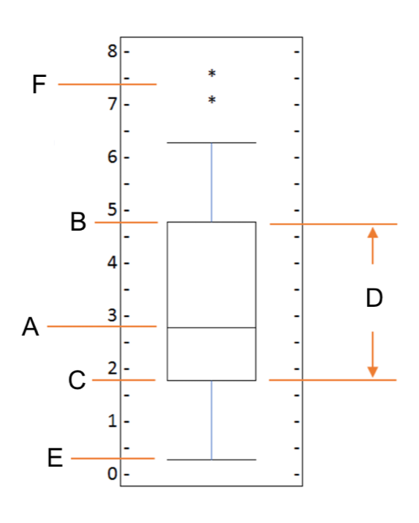

What do the letters in the box plot above represent?



A = Median, B = Third Quartile, C = Mean, D = Inter Quartile Range, E = Lower Quartile, and F = Outliers



A = Median, B = Third Quartile, C = First Quartile, D = Inter Quartile Range, E = Minimum, and F = Outliers



A = Mean, B = Upper Mean Quartile, C = Lower Mean Quartile, D = Inter Quartile Range, E = Minimum, and F = Outliers



A = Mean, B = Third Quartile, C = First Quartile, D = Inter Quartile Range, E = Minimum, and F = Maximum



A = Mean, B = Third Quartile, C = First Quartile, D = Inter Quartile Range, E = Minimum, and F = Outliers

**Correct**

Correct.

**1 / 1 point**

3.Question 3

What is the correct combination of function and parameter to create a box plot in Matplotlib?



Function = plot, and Parameter = kind with value = "boxplot"



Function = plot, and Parameter = kind with value = "box"



Function = box, and Parameter = type with value = "plot"



Function = boxplot, and Parameter = type with value = "plot"



Function = plot, and Parameter = type with value = "box"

**Correct**

Correct.

**1 / 1 point**

4.Question 4

Which of the lines of code below will create the following scatter plot, given the *pandas* dataframe, df_total?

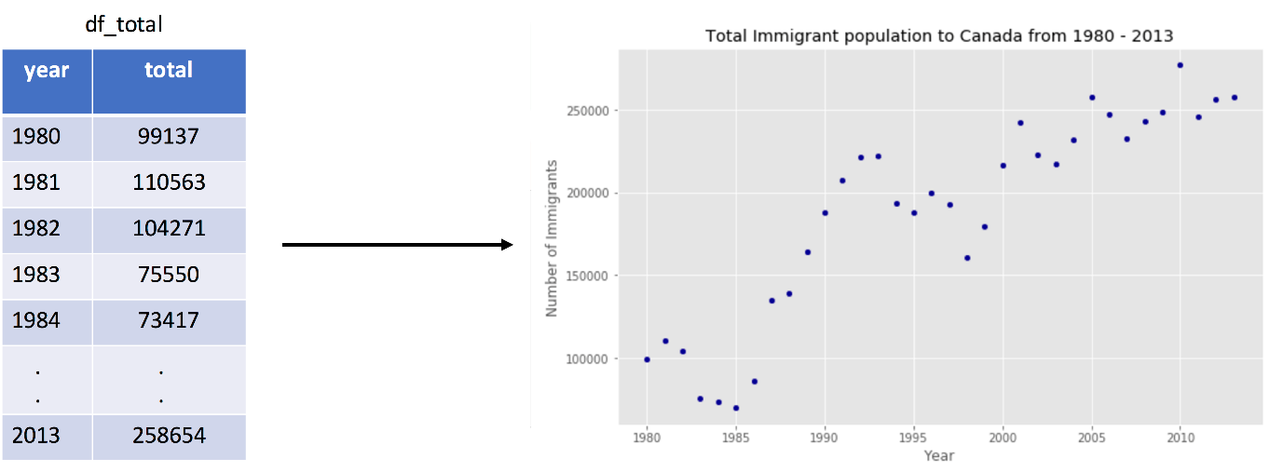





1

2

3

4

5

6

7

import matplotlib.pyplot as plt

plot(kind='scatter', x='year', y='total', data=df_total)

plt.title('Total Immigrant population to Canada from 1980 - 2013')

plt.label ('Year')

plt.label('Number of Immigrants')





1

2

3

4

5

6

7

import matplotlib.scripting.pyplot as plt

df_total.plot(type='scatter', y='year', x='total')

plt.title('Total Immigrant population to Canada from 1980 - 2013')

plt.xlabel ('Year')

plt.ylabel('Number of Immigrants')





1

2

3

4

5

6

7

import matplotlib.scripting.pyplot as plt

df_total.plot(kind='scatter', x='year', y='total')

plt.title('Total Immigrant population to Canada from 1980 - 2013')

plt.label('Year')

plt.label('Number of Immigrants')





1

2

3

4

5

6

7

import matplotlib.pyplot as plt

df_total.plot(type='scatter', x='year', y='total')

plt.title('Total Immigrant population to Canada from 1980 - 2013')

plt.label ('Year')

plt.label('Number of Immigrants')





1

2

3

4

5

6

7

import matplotlib.pyplot as plt

df_total.plot(kind='scatter', x='year', y='total')

plt.title('Total Immigrant population to Canada from 1980 - 2013')

plt.xlabel ('Year')

plt.ylabel('Number of Immigrants')

**Correct**

Correct.

**1 / 1 point**

5.Question 5

A bubble plot is a variation of the scatter plot that displays one dimension of data.



True.



False.

**Correct**

Correct.